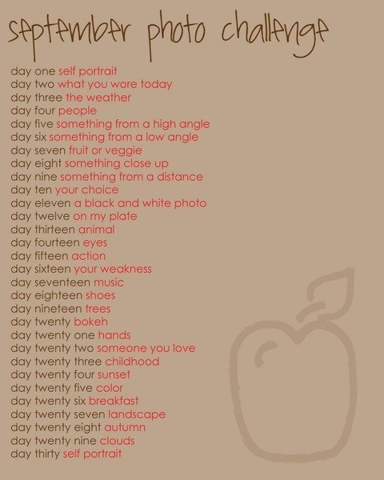
- Label each of the days with an actual date.
- You only need to do the week days.
- You will be graded based on your creativity and the composition. Low grades are given for low effort. Be different than your classmates.
- You need to instagram these pictures. They will be checked on Saturday for a grade.
- Take the best picture. It doesn’t matter if it is the exact day, but that means delete other tries so I know what to grade.
- Rubric is on the back.

Friday you must turn in your 200 words on one of your pictures. In your analysis you must tell me which picture you chose. Remember that you are to be creative in your description and pretend like it is going in the yearbook. You WANT people to read your stuff.

