ScaryFairies:
Culminating Point of View Project

To demonstrate your ability to analyze point of view, you have the opportunity to put a new spin on a classic fairy tale. Just as Jon Scieszka flipped the perspective of “The Three Little Pigs” when he wrote “The True Story of the Three Little Pigs,” you too will choose one tale to recreate into a scary story. Most Fairy Tales were actually written with scary or horrifying endings. You can google any of them to see some examples.

Standard W.8.3:
Write narrative to develop real or imagined experiences of events using effective technique, relevant descriptive details, and well-structured event sequences.
- Engage and orient the reader by establishing a context and point of view and introducing a narrator and/or characters; organize an event sequence that unfolds naturally and logically.
- Use narrative techniques, such as dialogue, pacing, and description, to develop experiences, events, and/or characters.
- Use a variety of transition words, phrases, and clauses to convey sequence and signal shifts from one time frame or setting to another
- Use precise words and phrases, relevant descriptive details, and sensory language to capture the action and convey experiences and events.
- Provide a conclusion that follows from and reflects on the narrated experiences or events.

Below is a list of popular fairy tales you could consider for your project:

Little Red Riding Hood Hansel and Gretel Rapunzel Rumpelstiltskin
Snow White Cinderella Sleeping Beauty Peter Pan
Jack and the Beanstalk The Ugly Duckling The Frog Prince

Upon completion of a rough draft, you will have a proficient reader revise/edit your tale.

My proficient reader will be __________________________________________________

Significant Due Dates:

Prewriting/Planning Activity: ________10/9______________
Rough Draft 1: ______10/13________________
Proficient Reader: ___10/14___________________
Final Product (typed and perfect): ___10/16___________________SUBMIT VIA GOOGLE DOCS
Name: ___________________________ p. _____

Scary Fairy Rubric

Exemplar (73 – 75 points)
ALL proficient plus…
Score out of 75: _________
___ Strong sense of voice (personal tone and flavor)
___ Artful writing that paints a picture for the reader

Proficient (60 – 72 points)
___ A creative or inviting title is present (the title should do more than simply state the topic)
___ Contains cover and title page that are visually appealing
___ Point of view represented is a recognizably flipped version of a classic fairy tale
___ Narrative point of view is consistent throughout the text
___ Includes at least two fully developed characters with distinct personalities/viewpoints
___ Includes at least one paragraph of setting description that uses a minimum of three figurative language devices
___ Meaningful dialogue used to enhance the plot
___ Dialogue includes narrations so the reader stays oriented with the actions and emotions of the characters
___ Clearly developed beginning where the main conflict is introduced
___ Clearly developed middle where the protagonist makes two attempts to solve the main conflict
___ Resolution provides logical closure to conflict and story events
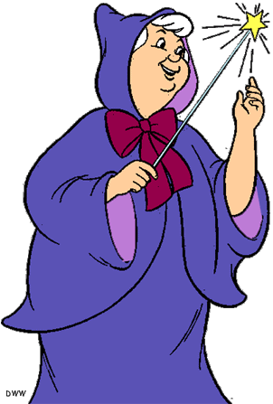
___ Event sequence unfolds naturally and logically
___ A variety of transition words are used to convey shifts in sequence, time, and setting
___ Contains a minimum of five power sentences (dependent clause + strong verb + adjective/description)
___ Proper comma placement in various sentence types (100% accuracy)
___ Fewer than six editing errors
___ Any errors in conventions do not interfere with readability
___ Each page contains an original, full-color illustration that is relevant to story
___Spelling has been checked

Close (53 – 59 points)
___ Meets 14-15 of proficient criteria

Far (fewer than 53 points)
___ Meets fewer than 14 of proficient criteria
*Please see me during advisory, so we can work together to achieve a proficient score

